**Cyngor Sir CEREDIGION County Council**

# **Public Consultation**



# **Ceredigion Household Waste Sites**

**This consultation is available electronically at:** [**Review of Household Waste Sites - Ceredigion County Council**](https://cccumbracolive.azurewebsites.net/your-council/consultations/review-of-household-waste-sites/)

**This document is available in alternative formats, such as large print or with a coloured background. For more information, please phone 01545 570881 or email** [**clic@ceredigion.gov.uk**](mailto:clic@ceredigion.gov.uk)

## **Share your views:**

You can share your views by:

Completing a feedback form online: [Review of Household Waste Sites - Ceredigion County Council](https://cccumbracolive.azurewebsites.net/your-council/consultations/review-of-household-waste-sites/)

Or by returning this feedback form to us at one of our Libraries or Leisure Centres or by post to the address below:

Waste Management Team

Ceredigion County Council

Ceredigion County Hall Penmorfa

Aberaeron

Ceredigion

SA46 0PA

## **Contact us:**

By e-mail: [clic@ceredigion.gov.uk](mailto:clic@ceredigion.gov.uk)

By phone: 01545 570881

The closing date for feedback is Monday 4th August 2025.

## **Current Household Waste Sites**

There are currently four Household Waste Sites in Ceredigion, which is one of the highest number of sites per person in Wales:

* Cilmaenllwyd near Cardigan
* Glanyrafon Industrial Estate near Aberystwyth
* Lampeter
* Rhydeinon near Llanarth

The current opening hours at Cilmaenllwyd, Glanyrafon and Lampeter sites are:

* 9:00 - 17:00 Monday – Friday.
* 10:00 – 15:00 Weekends and Bank Holidays.
* The site at Rhydeinon is open Wednesday, Saturday and Sunday 10:00-17:00.

All sites are closed on Good Friday, Christmas Day and New Year’s Day.

The location of each site is shown in the map below.

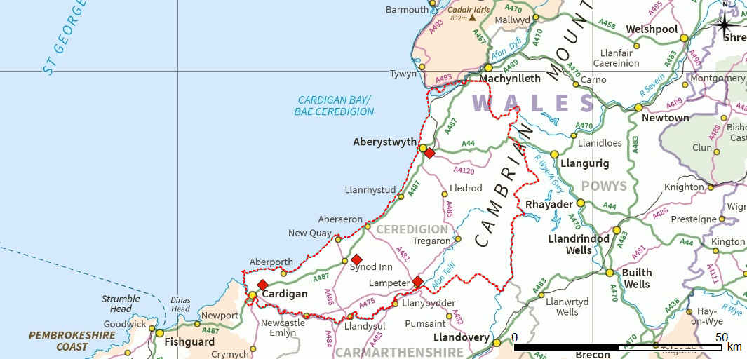

**GLANYRAFON**

**CILMAENLLWYD**

**RHYDEINON**

**LAMPETER**

The Household Waste Site near Aberystwyth serves the north of the county and the site near Cardigan serves the south. There are two sites covering the middle of the county.

|  |  |
| --- | --- |
| Household Waste Site | Tonnage accepted  12 months to December 2024 |
| Cilmaenllwyd near Cardigan | 1,459.09 |
| Glanyrafon near Aberystwyth | 4,098.55 |
| Lampeter | 2028.18 |
| Rhydeinon near Llanarth | 1107.96 |

Most of the materials accepted at the Household Waste Sites can be disposed of legally and safely in other ways.

* Around 25% of the waste taken to the sites is garden waste which could be home-composted or collected through the Council’s Garden waste service
* Paper, card, plastics, cans and cartons can be put in your clear bags, collected from the kerbside every week
* Glass bottles and jars can be put in your kerbside box, collected every 3 weeks, or put into one of the county’s glass banks
* Textiles, bric-a-brac and furniture can be reused by selling or donating them
* Non-recyclable waste that can be put into your non-recyclable waste container and collected from the kerbside every 3 weeks
* Large items that aren’t suitable for sale or donation can be collected through the Council’s bulky household waste service

## **The need for change – costs and budgets**

In the meeting of Ceredigion County Council held on 29 February 2024, Councillors heard that the Welsh Government had openly stated that their 24/25 Draft Budget is ‘the starkest and most painful since devolution’ It was also Ceredigion County Council’s starkest Budget yet.

A Budget shortfall of £14m needed to be found from a combination of budget reductions and Council Tax increase considerations. Councillors therefore had to face incredibly difficult and unpalatable budget choices as part of weighing up how and where to reduce the cost of Council services.

As a result, 70 budget reductions proposals were put forward including a proposal to “Review opening hours across all Household Waste Sites, including closure of 1 Site” to reduce the current costs of around £1.5 million by £100,000 per year.

## **The need for change – the future**

The waste industry is constantly changing, as is waste legislation. In order for Ceredigion to meet the needs of today, and to be better prepared to meet the needs of tomorrow, the facilities at the county’s Household Waste Sites may need to be improved, and the sites may need to be extended to accommodate such improvements. None of the sites are ideal for meeting future needs, and all four sites have limited opportunities for expansion.

Work will shortly be commencing to consider options for Council’s future waste services including household waste sites. In the meantime, we need to find the short-term cost saving identified by the Council in February 2024, as we simply can’t afford to keep all sites open.

Since this council meeting, we have been considering several options.

## **Options**

* Close or suspend use of the Cilmaenllwyd Household Waste Site or reduce the opening hours.
* Close or suspend use of the Glanyrafon Household Waste Site or reduce the opening hours.
* Close or suspend use of the Lampeter Household Waste Site or reduce the opening hours.
* Close or suspend use of the Rhydeinon Household Waste Site or reduce the opening hours.

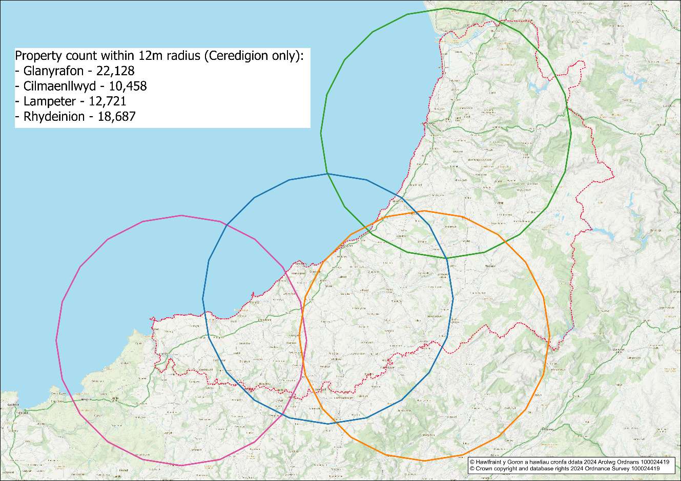

Map 1- showing all four sites, each circle represents a radius of 12 miles

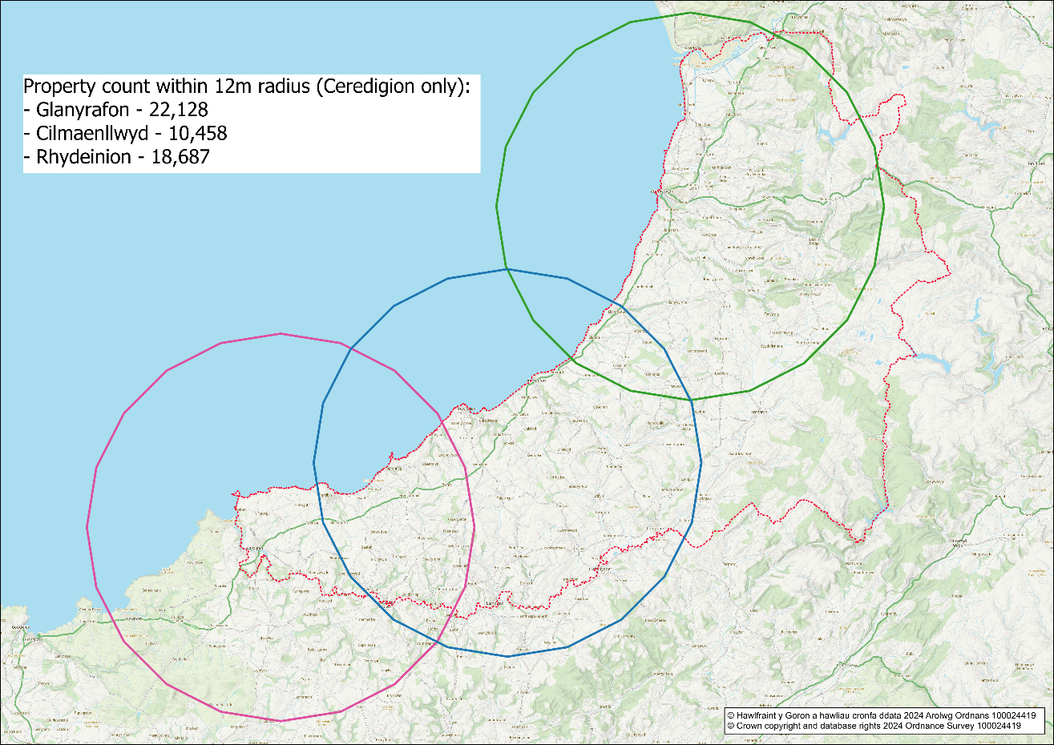

Map 2 - showing sites at Glanyrafon, Cilmaenllwyd and Rhydeinon

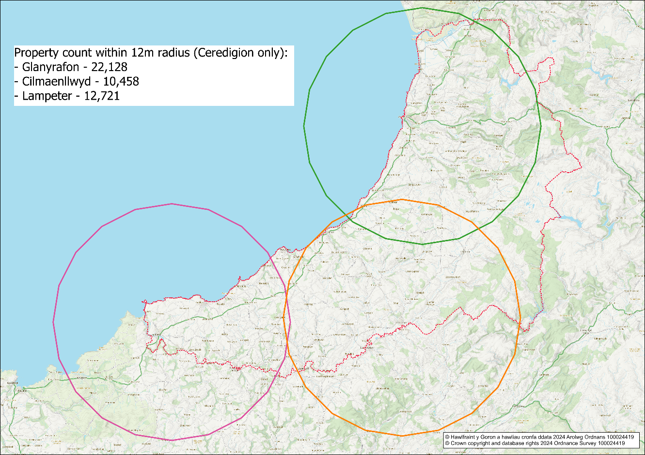

Map 3- showing sites at Glanyrafon, Cilmaenllwyd and Lampeter

Map1 indicates that there is an overlap between the three Household Waste Sites in the south of the County.

The site at Glanyrafon is the only site in the north of the county, it is also the busiest both in terms of number of site users and weight of material accepted each year. For these reasons, we would prefer to keep it open.

Cilmaenllwyd provides a facility for residents in the southwest of the County. The sites at Rhydeinon and Lampeter provide sites for residents in mid-Ceredigion. Map 1 illustrates that the greatest degree of overlap is between the sites at Rhydeinon and Lampeter.

Closing one of the two mid-county sites would align with our Corporate Strategy 2017–2022, which states: 'It is the intention of the Council to align future service provision with three geographical areas.

## **Proposal**

We feel that suspending use of Rhydeinon site and maintaining opening hours at the other sites would have the least amount of impact on residents.

It is proposed to suspend use of the Rhydeinon Household Waste Site, until such time as the review of the Council’s waste services is complete, and a longer-term strategy for the Council’s Household Waste Sites is developed.

We expect this to increase the volumes of traffic around the sites at Cilmaenllwyd and Lampeter. For this reason, it is not currently proposed to reduce the hours at the other sites. Site usage will continue to be monitored and a reduction in opening hours at the remaining sites may be considered again in the future.

## **Feedback Form**

Please return this form to us at one of our Libraries or Leisure Centres or by post to the address below:

Waste Management Team, Ceredigion County Council, Rhodfa Padarn, Llanbadarn Fawr, Aberystwyth, SY23 3UE.

**Question 1: How often do you use the current Household Waste Sites?**

|  |  |
| --- | --- |
| Daily |  |
| Weekly |  |
| Monthly |  |
| Rarely |  |
| Never |  |

**Question 2: Which Household Waste Site do you currently use most often?** (tick one box only)

|  |  |
| --- | --- |
| Cilmaenllwyd |  |
| Glanyrafon |  |
| Lampeter |  |
| Rhydeinon |  |

**Question 3: Would the suspension of use of Rhydeinon Household Waste Site have a direct impact on you or your family?**

|  |  |
| --- | --- |
| Yes, please go to question 4 |  |
| No, please go to question 5 |  |

**Question 4: Please explain the impact that suspension of use of the Rhydeinon Household Waste Site would have on you and your family.**

|  |
| --- |
|  |

**Question 5: If you do not agree to the proposal, please explain which site you would prefer to be suspended, and why your choice would have the least impact on Ceredigion residents.**

|  |
| --- |
|  |

**Question 6: Do you agree that the Council should keep the opening hours unchanged for the Glanyrafon, Cilmaenllwyd and Lampeter Household Waste Sites while monitoring takes place?**

|  |  |
| --- | --- |
| Yes |  |
| No, please go to question 7 |  |

**Question 7: Please explain why you would prefer the opening hours to reduce at the Glanyrafon, Cilmaenllwyd and Lampeter Household Waste Sites.**

|  |
| --- |
|  |

## Welsh Language Impact

To ensure that we comply with the Welsh Language Standards we must consider the effect that any change in policy may have on the Welsh language.

1. Do you think that this proposal, in its current draft form, will have an effect on opportunities for people to use the Welsh language and on the status of the Welsh language in the community?

* Yes, a positive effect.
* Yes, a negative effect.
* It will not have an effect.

1. Please use the space below to add further comments about the effect on the Welsh language.
2. Do you think this proposal could be revised to increase any positive effects or reduce any negative effects on opportunities for people to use the Welsh language and on the status of the Welsh language in the community? If so, how?

## Equality Monitoring Form

You do not have to answer these questions. They help us to check that we have collected the views of a broad range of people that truly reflect the population in Ceredigion. The information will only be used for statistical analysis.

**1. How old are you?**

* 0-15
* 16-24
* 25-44
* 45-64
* 65+
* I prefer not to say

**2. What gender do you identify as?**

* Male
* Female
* Non-binary
* Trans-gender
* I prefer to use another term
* I prefer not to say

**3. Which of the following best describes how you think of yourself?**

* Heterosexual/straight
* Gay, Lesbian or Queer
* Bisexual
* Another sexual orientation
* I prefer not to say

1. **How would you describe your national identity?**

* British
* Cornish
* English
* Northern Irish
* Scottish
* Welsh
* Another national identity
* I prefer not to say

**5. How would you describe your ethnic group?**

* Asian, Asian British or Asian Welsh
* Black, Black British, Black Welsh, Caribbean or African
* Mixed or Multiple ethnic
* White
* Another ethnic group
* I prefer not to say

**6. What is your religion or belief?**

* Christian
* Buddhist
* Hindu
* Jewish
* Muslim
* Sikh
* No religion
* Other religion or belief
* I prefer not to say

**7. Have you previously served in the UK Armed Forces?**

(current serving members should tick 'no')

* Yes, in the Regular Armed Forces
* Yes, in the Reserve Armed Forces
* No
* I prefer not to say

**8. Do have a long term physical or mental health condition or illness that reduces your ability to carry out day-to-day activities?**

* Yes, my day-to-day activities are limited a lot
* Yes, my day-to-day activities are limited a little
* No
* I prefer not to say

**9. What is your preferred language?**

* Welsh
* English
* I prefer not to say

**10. Can you understand, speak, read or write Welsh?**

* Understand spoken Welsh
* Speak Welsh
* Read Welsh
* Write Welsh
* None of the above
* I prefer not to say

## Thank you for completing this consultation.

Please return this form to us at one of our Libraries or Leisure Centres or by post to the address below:

Waste Management Team

Ceredigion County Council

Ceredigion County Hall Penmorfa

Aberaeron

Ceredigion

SA46 0PA

## **Contact us:**

By e-mail: [clic@ceredigion.gov.uk](mailto:clic@ceredigion.gov.uk)

By phone: 01545 570881

The closing date for feedback is Monday 4th August 2025.

## What happens next?

* The results of this consultation will be analysed.
* The Integrated Impact Assessment will be updated, based on consultation feedback.
* The draft proposal, consultation report and Impact Assessment will be presented to our Thriving Communities Scrutiny committee on 24th September 2025. They will scrutinise the documents and provide feedback.
* All of the documents, including feedback from Scrutiny, will be presented to Cabinet for a decision on the 7th October 2025.
* The details of the final agreed proposal will inform the tender process for new Waste Management contracts.
* Should the proposal be agreed, the change would start 1 February 2026.